**Climate change in the global south and the global north [group I]**

Climate change and pacific islands

**Tasks**

1. Describe the main problems that climate change is causing for island states such as Tuvalu and Kiribati.
2. Explain the social, cultural and economic impacts on the inhabitants of these island states.
3. Explain why the situation of the island states is an example of climate justice issues.
4. Discuss who is responsible for supporting these island states and justify your opinion.

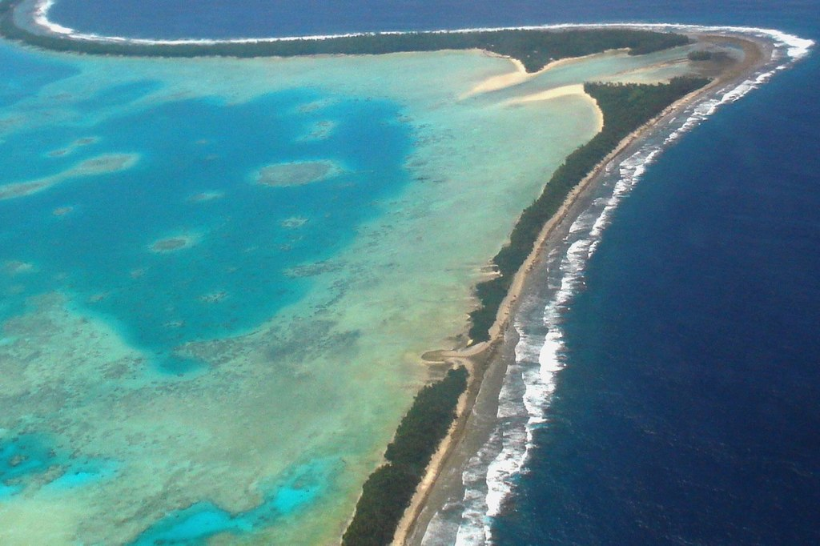

Foto: Lily-Anne Homasi/DFAT, CC BY 2.0 <https://creativecommons.org/licenses/by/2.0>, via Wikimedia Commons

Tuvalu is an island state in the South Pacific and, like the Fiji Islands, Kiribati, New Zealand and Australia, is part of the continent of Oceania. The capital and largest island of the state is Funafuti. The name Tuvalu means "eight islands", as only eight islands were inhabited when the state was founded in 1978. The current land area of Tuvalu comprises nine atolls and around 1,000 small islands and corresponds to an area of 26 km². This makes Tuvalu the fourth smallest state in the world. The widest point of the country measures only about 400 meters, while the average sea level is about two meters above the land.

The islands of Tuvalu have been inhabited by humans for at least 2,000 years, with the current population standing at around 10,400. The population of Tuvalu is facing a serious threat from climate change and the associated rise in sea levels. This results in flooding, loss of land and a shortage of drinking water supplies. Although Tuvalu has contributed to global warming to a lesser extent than other countries, the effects of climate change are devastating for the country.

The climate impacts require people to reflect on their future. On the Fiji Islands, entire settlements have already disappeared into the ocean, making it necessary to relocate the affected population to higher regions of the island state. These initial relocations due to rising sea levels have saved the lives of those affected, but they face considerable challenges as they have to rebuild their livelihoods, including the creation of new fish ponds, agricultural land and coastal protection measures. The costs of these resettlements are borne by the residents and the Fijian government, which many feel is unfair as they have contributed little to nothing to climate change.

The island state of Kiribati in the South Pacific is also unable to relocate all of its inhabitants to higher ground. The Kiribati government therefore acquired an area of 2,428 hectares on Fiji's second largest island, Vanua Levu, for 16 million Fiji dollars (the equivalent of around seven million euros) back in 2016. The plan envisages that people from Kiribati will live on this land in the future. The land is home to the village of Naviavia with 261 inhabitants who fear displacement. Following the visits and discussions, it was agreed that the village would remain and the land would be developed in the interests of the villagers.

Anote Tong, the former president of Kiribati, was already committed to "migration with dignity" for his compatriots before the climate summit in Paris in 2015. The inhabitants of Kiribati do not want to be labelled as climate refugees. Resettlement to a landlocked country in a highly developed industrialised nation such as Australia, which has no access to the sea, would be particularly difficult for those affected, as their lives are largely characterised by fishing.

The people of Tuvalu, on the other hand, do not want to leave their homeland. For them, resettlement is not an acceptable solution.

**Climate change in the global south and the global north [group II]**

Water in Bangladesh

**Tasks**

1. Describe the main problems that climate change is causing for Bangladesh.
2. Explain the social, cultural and economic impacts on the people of Bangladesh.
3. Explain why the situation in Bangladesh is an example of climate justice issues.
4. Discuss who is responsible for supporting this country and justify your opinion.

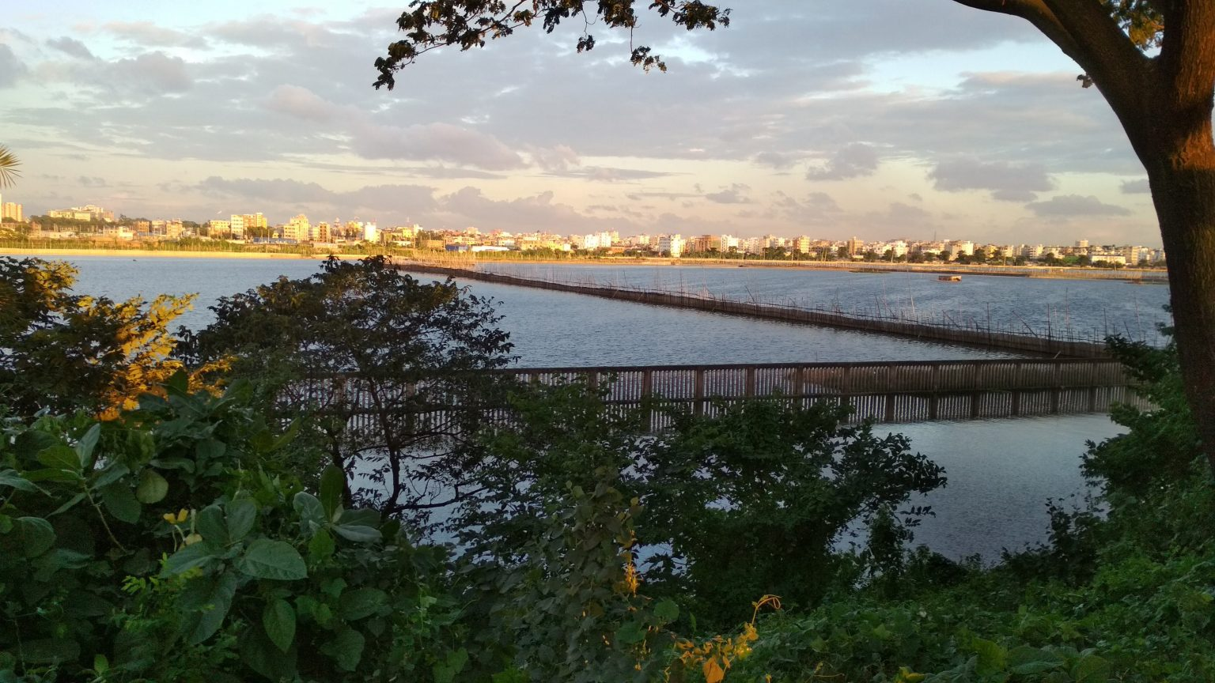

CC0 licensed photo by Jakaria Istauk from the WordPress Photo Directory.

The People's Republic of Bangladesh is surrounded by the states of India, Myanmar and the Indian Ocean. The country's capital is Dhaka and the national language is Bengali. The country was a British colony until 1947 and then belonged to Pakistan. The country has enjoyed independence since 1971. Bangladesh is one of the economically weakest countries in the world and is highly dependent on the textile industry. Another important sector for the country's economy is agriculture. The population density is one of the highest in the world. The country is characterised by low topographic diversity and in many places has only a low elevation above sea level. One third of the national territory is coastal. The threat to Bangladesh from rising sea levels and other effects of climate change, such as storms and flooding, is evident. In this regard, however, it should be noted that Bangladesh only makes a small contribution to global CO₂ emissions.

The rivers of the Ganges-Brahmaputra delta are fed by water that rains down on the Himalaya. As a result, floods occur almost every year along the major rivers, depositing sediments and making the land fertile. However, excessively long and early floods result in crop losses and great hardship for the population. The floods from the direction of the ocean lead to salinisation of the soil and groundwater. The current situation is characterised by the fact that fresh water is already scarce. Between 1973 and 2009, the area of land with a high salt content increased by 20 per cent. It can also be observed that rice has stopped growing many kilometers inland.

Natural flood protection is provided by mangroves, which are trees that grow in salt water. Rising sea levels are damaging the roots, threatening numerous rare plants and animals as well as the people in the hinterland. More than 60 per cent of all tropical cyclones on earth occur in the Bay of Bengal. The storm surges flood soils and water bodies, causing these soils to become saline. The shortage of fresh water leads to a lack of drinking water and crop failures. In addition, the monsoon, which brings large amounts of rainwater, is becoming increasingly unreliable due to climate change. As a result, many farmers are no longer growing rice but are flooding their land to grow prawns and other seafood. This further increases the salinisation of land and soil. The poor sections of the population in particular are suffering from the consequences of climate change. They are forced to adapt to climate change. Bangladesh's share of global CO₂ emissions is comparatively low. In 2018, average per capita CO₂ emissions in Bangladesh were 0.56 tonnes, compared to 9.15 tonnes in Germany.

**Climate change in the global south and the global north [group III]**

Flood in the Ahr valley (Germany)

**Tasks**

1. Describe the main problems caused by the flood in the Ahr valley.
2. Explain the social, cultural and economic impacts on the inhabitants of the Ahr valley.
3. Research how the reconstruction of destroyed areas after extreme weather events is carried out in the Global South and how it is financed.
4. Discuss who is responsible for supporting people and maintaining infrastructure and give reasons for your opinion.

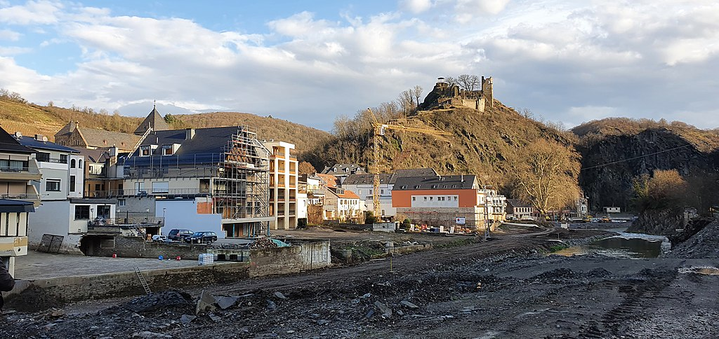

CC BY-SA 4.0 <https://creativecommons.org/licenses/by-sa/4.0>, via Wikimedia Commons

Intense heavy rainfall events occurred in Germany and neighbouring countries in July 2021 in connection with the "Bernd" weather low. These led to severe flooding, particularly in the Ahr valley, which claimed over 180 lives and caused considerable damage to the infrastructure. Houses, roads, railway tracks and much more were destroyed and had to be rebuilt. The financial damage is considerable. After the devastating flood disaster, various support measures were initiated. Firstly, there was emergency aid for those affected to cover urgent needs such as accommodation. The responsible authorities made 800 million euros available for this purpose.

An extensive fund with a volume of up to 30 billion euros was set up for long-term reconstruction. Of this, 12.3 billion euros are earmarked for North Rhine-Westphalia and 15 billion euros for Rhineland-Palatinate, with Saxony and Bavaria also being taken into account. Funding will be provided in equal parts by the federal and state governments.

Local authorities, associations, companies and private individuals are eligible for assistance from this fund. The funds can be applied for various purposes, including the demolition of buildings, renovation work or new construction. There are also lump sums for destroyed household goods.

The aim of these measures is to provide comprehensive support for reconstruction in the affected areas and to help people cope with the consequences of the floods.

The flood disaster put the climate debate at the centre of the 2021 federal election campaign, but the question arises as to whether a direct link can be established between climate change and this specific event, especially in light of historical incidents of heavy rainfall and flooding.

Scientific studies are based on extensive simulations over long periods of time and various scenarios. Although no model can predict with certainty whether a particular event would have occurred without climate change, the results indicate that such extreme weather events would occur much less frequently in a world without climate change.

With regard to the Ahr Valley, a study from August 2021 found that such extreme rainfall events could be expected statistically every 400 years in a typical Western European region. However, climate change has increased this probability by a factor of 1.2 to 9, meaning that such events could now potentially occur every 50 years.

These findings emphasise the complexity of climate research and the challenges of attributing individual events to climate change, but also clearly show the increased risks posed by global warming.

Bonn geographer Thomas Roggenkamp says: "The floods of July 2021 should be categorised as an extreme, but not unique, event. Similar events are known to have occurred in pre-industrial times".

The direct causality between climate change and the specific flood disaster in the Ahr valley cannot be established beyond doubt. However, scientific findings indicate that global warming can significantly increase the frequency and intensity of such extreme weather events. This means that similar disasters could possibly occur more frequently and with greater severity in the future, even if climate change cannot be identified as the sole cause of an individual event.

**Climate change in the global south and the global north [group IV]**

Drought in Ethiopia

**Tasks**

1. Describe the main problems caused by climate change in Ethiopia.
2. Explain the social, cultural and economic impacts on the people of Ethiopia.
3. Explain why the situation in Ethiopia is an example of climate justice issues.
4. Discuss who is responsible for supporting this country and give reasons for your opinion.

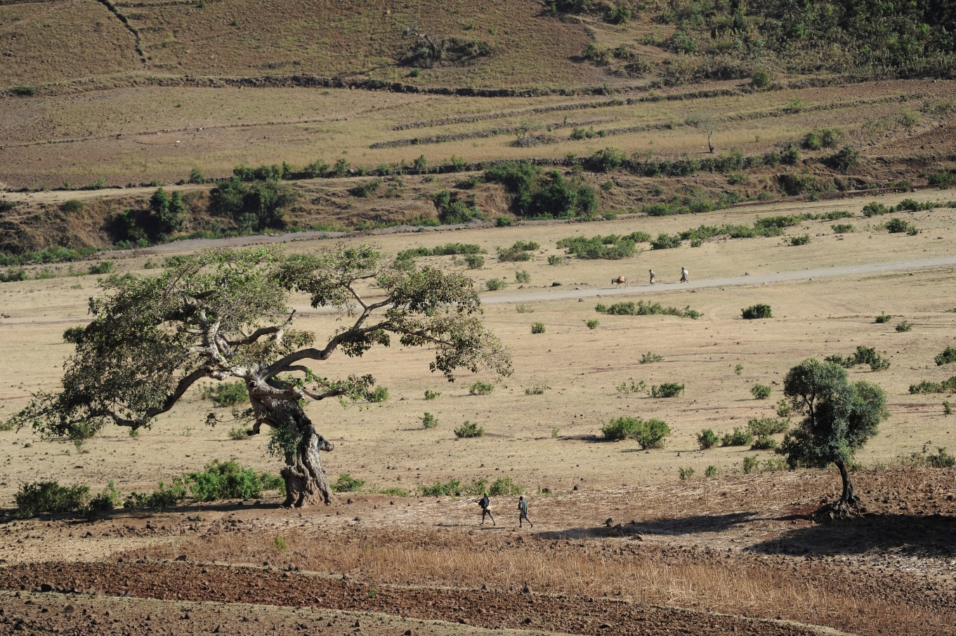

© Reli furs Klima, Brot für die Welt

Ethiopia, an East African country with around 115 million inhabitants. The Horn of Africa region, which includes Ethiopia, is suffering from a severe drought due to climate change that is affecting millions of people. In some regions, it has not rained for several years.

100 years ago, 40 per cent of Ethiopia was still forested, which corresponds to almost half of the country. Since then, the population has grown considerably and extreme weather events have increased, meaning that food security is no longer guaranteed. Forests have been cleared to make room for agricultural land to feed the population and combat hunger. A speciality of Ethiopia are the 800-year-old church forests that surround the numerous churches and monasteries in the north of the country. These forests are home to indigenous tree species and serve as a habitat for various animal and bird species. They fulfil important ecological functions and also have cultural and religious significance. Despite their importance, these church forests are also increasingly under threat as the local population is forced to cut down trees and sell the wood due to food shortages. Dependence on agriculture combined with the effects of climate change is exacerbating the situation for many people in Ethiopia, as rainfall is becoming increasingly scarce.

The people of Ethiopia are already suffering from the consequences of climate change, to which other countries are making a major contribution.

In 2022, carbon dioxide (CO₂) emissions in Ethiopia averaged around 0.15 tonnes per inhabitant. In a global comparison, the average value is around 4.66 tonnes per capita.

In comparison, Germany's per capita emissions are around 7.99 tonnes. The high carbon dioxide content in the earth's atmosphere contributes to an increase in global temperatures, which in turn affects the environment.